# CHAPTER 1

**INTRODUCTION**

The Face Recognition Based Attendance Monitoring System is to develop a reliable and efficient automated attendance tracking system using facial recognition technology. This system aims to replace traditional attendance methods, such as manual roll calls or card-based systems, with a more secure and user- friendly approach. By leveraging computer vision and machine learning techniques, the system will accurately recognize and record the attendance of individuals in real-time, thereby reducing the chances of proxy attendance and improving the overall efficiency of attendance management.

**PROBLEM STATEMENT**

Transitioning to Al-based facial recognition can streamline attendanc management, Facial recognition reduces manual errors and enhances system accuracy, Modern systems provide better control, visibility, and insights for institutions, This shift improves overall operational efficiency.

## OBJECTIVES

The objective of the Face Recognition Based Attendance Monitoring System are:

1. **Development of Face Recognition Model**: Implementing a robust face recognition algorithm using pre-trained models (e.g., Haar Cascade, LBPH, etc.) to accurately identify individuals.
2. **Data Management**: Creating a database to store student details, attendance records, and training images.
3. **User Interface**: Developing a user-friendly interface for both administrators and users to interact with the system, including functionalities for registration, attendance marking, and report generation.
4. **Real-time Attendance Tracking**: Integrating a camera to capture live video streams for real-time face recognition and attendance logging**.**
5. **Security and Privacy**: Ensuring the system is secure and respects user privacy by implementing appropriate data protection measures.
6. **Reporting and Analytics**: Generating detailed attendance reports and analytics to help administrators monitor attendance patterns and take necessary actions.
7. **Scalability and Integration**: Designing the system to be easily scalable and integrable with existing school or corporate management systems.
8. **Cross-Platform Accessibility**: Developing the system to be accessible across multiple platforms, including desktop and mobile devices.

# CHAPTER 2

**2.1 Year: 2024**

# LITERATURE SURVEY

**Title:** Automating attendance management in human resources: A design science approach using computer vision and facial recognition.

**Authors:** Bao-Thien Nguyen-Tat,Minh-Quoc Bui, Vuong M. Ngo

**Methodology:** DSRM is a structured approach for creating and evaluating IT artifacts aimed at solving identified problems. The key phases in this methodology include:

* **Objectives Definition:** Shaping the pursuit of a system that integrates embedded computing with advanced face recognition technologies.
* **Problem Identification and Motivation:** Recognizing the need for an efficient, accurate, and cost- effective face recognition system for attendance management.

### Remarks:

* **Potential Benefits:** The system offers significant improvements over traditional attendance methods, including reduced errors, increased efficiency, and cost savings.
* **Comprehensive Approach:** The approach involves detection, extraction, labeling, and face recognition, ensuring a seamless and integrated process.

### 2.2 Year: 2023

**Title:** Anti**-**spoofing-enabled Contactless Attendance Monitoring System in the COVID-19 Pandemic. **Authors:** Deepti Saraswat, Pronaya Bhattacharaya, Trith Shah, Rushi Satani,Sudeep Tanwar **Methodology:** The authors propose a contactless attendance marking system that utilizes image processing and deep learning techniques to detect and recognize faces.

* **Mobile Application for Face Scanning**: The authors develop a mobile application using Google Vision API to capture face images when an employee/student comes in front of the camera.
* **Face Recognition:** The authors use the dlib library, a popular open-source face recognition package, to identify individuals. A Python package, face recognition dlib capabilities into API.

### Remarks:

* The proposed system is contactless, reducing the hassle and burden of traditional attendance marking systems.
* The system is scalable and can be deployed in various settings, including educational institutions and workplaces**.**

### 2.3 Year: 2022

**Title:** Student attendance with face recognition (LBPH or CNN): Systematic literature review **Authors:** Andre Budiman, Fabiana, Ricky Aryatama Yaputera, Said Achmad, Aditya Kurniawan **Methodology:**

* The study employs a Systematic Literature Review (SLR) methodology to compare various algorithms for face recognition.
* The literature review was conducted using search strategy to gather relevant studies from Google Scholar. The PRISMA framework was utilized to structured and transparent review process.

### Remarks:

* The paper highlights the rapid advancement of technology and its application in solving student attendance issues at universities. Traditional methods such as manual attendance and RFID-based systems have limitations, including potential cheating and the need for physical cards.
* Face recognition technology offers a more reliable solution by using students' faces for attendance, reducing the chances of manipulation and human error.

### 2.4 Year: 2021

**Title:** Using Barcode to Track Student Attendance and Assets in Higher Education Institutions

**Authors:** Salah Elaskari (Dalhousie University),Muhammad Imran (University of Tabuk), Abdurrazag Elaskri (Carleton University), Abdullah Almasoudi (University of Tabuk).

### Methodology:

The paper employs a practical implementation approach to explore the use of barcode technology for tracking student attendance and assets in higher education institutions. The study includes:

* **Historical Overview:** A review of the development and types of barcode technology.
* **System Design:** Details on the implementation of technology for attendance and asset tracking.
* **Usability Study:** Evaluation of the system's usability, comfort level, and efficiency from the perspectives of faculty and staff.

### Remarks:

The authors identify several drawbacks of manual attendance and asset tracking methods, such as data entry errors and loss of lecture time. Key findings include:

* **Efficiency and Accuracy:** Barcode technology significantly reduces data entry errors and improves the efficiency of recording attendance and tracking assets.
* **Cost-Effectiveness:** This is cost-effective, requiring minimal investment in creating barcode tags and hardware. Faculty and staff reported satisfaction with the system usability and efficiency.

# CHAPTER 3

**SYSTEM REQUIREMENTS AND SPECIFICATIONS**

## SCOPE OF THE PROJECT

The scope of the project is to design and develop a contactless attendance marking system using image processing and deep learning techniques.

* The system aims to provide an efficient, accurate, and secure way to mark attendance in various settings, such as educational institutions and workplaces.
* Designing and implementing a face recognition system using deep learning techniques.
* Creating a database module for storing and retrieving attendance data.
* Developing an anti-spoofing module for liveness detection.
* Integrating the modules to create a seamless attendance marking system.
* Developing a mobile application for face scanning and image capture.
* Testing and evaluating the system's performance and accuracy.

## SOFTWARE REQUIREMENTS

* **Programming Language:** Python
* **Libraries and Frameworks:** OpenCV, NumPy, Pandas, Tkinter (for GUI)
* **Database:** SQLite or MySQL
* **IDE:** Visual Studio Code, PyCharm, or Jupyter Notebook
* **Operating System:** Windows, macOS, or Linux

## HARDWARE REQUIREMENTS

* **Processor:** Intel i5 or higher
* **RAM:** 8 GB or higher
* **Storage:** 500 GB HDD or SSD
* **Camera:** HD webcam or equivalent for capturing images

# CHAPTER 4

**SYSTEM ANALYSIS**

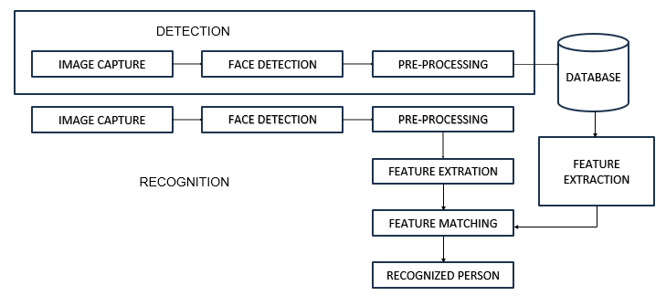

## Fig 4.1 PROPOSED WORKFLOW DIAGRAM

## 

## ARCHITECTURE DIAGRAM:

**Existing Systems**

### Manual Attendance:

* + **Process:** Teachers manually call out names and mark attendance on paper.

### Challenges:

* + - Time-consuming, especially for large classes.
    - Prone to human errors.
    - Difficult to maintain and retrieve historical records.

### Biometric Systems:

* + **Process:** Students use fingerprint or iris scanners to mark attendance.

### Challenges:

* + - Requires physical contact, which can be unhygienic.
    - Equipment can be expensive and prone to wear and tear.
    - Can lead to delays if multiple students need to mark attendance simultaneously.

### Card-Based Systems:

* + **Process:** Students swipe or scan ID cards to register attendance.

### Challenges:

* + - Cards can be lost, forgotten, or swapped among students.
    - Still requires physical interaction, which can be inconvenient.

## Limitations of Existing Systems

1. **Time Consumption:** Manual methods and even some biometric systems can be slow, particularly in large classes or institutions.
2. **Accuracy:** Human errors in manual systems can lead to incorrect attendance records.
3. **Hygiene:** Biometric systems requiring touch can be unhygienic, especially in situations like the COVID-19 pandemic.
4. **Forgery:** Card-based systems can be easily manipulated, leading to inaccurate attendance records.
5. **Legal and Regulatory Challenges**: Many jurisdictions have yet to establish clear guidelines and regulations regarding the use of facial recognition technology.
6. **User Acceptance**: Not all individuals may be comfortable with their biometric data being used for attendance purposes.
7. **Security Risks**: Biometric data, once compromised, cannot be changed like passwords. Therefore, ensuring the security of stored biometric data is critical to prevent identity theft and other malicious activities.
8. **Scalability**: While facial recognition systems can work well in controlled environments (like offices), scaling them to larger or more dynamic settings (such as outdoor events or busy public areas) can be challenging due to the need for more sophisticated algorithms and hardware.

# CHAPTER 5

**PROPOSED METHODOLOGY**

## 5.1Methodology:

### Data Collection and Preprocessing:

* + **Student Registration:**
    - Capture multiple images of each student.
    - Store images and student details (e.g., name, ID) in a structured database.

### Image Preprocessing:

* + - Convert images to grayscale to reduce computational complexity.
    - Normalize images for consistent input to the face recognition model.

### Face Detection:

* + **Using Haar Cascades:**
    - Utilize OpenCV's Haar Cascade Classifier to detect faces in real-time from a live camera feed.
    - Implement multi-scale detection for accurate face detection.

### Bounding Box Extraction:

* + - Draw bounding boxes around detected faces for further processing.

### Face Recognition:

* + **Model Selection:**
    - Choose a suitable face recognition algorithm (e.g., LBPH, Eigenfaces, Fisherfaces).

### Training the Model:

* + - Train the model using preprocessed images from the registration process.
    - Store the trained model for future recognition tasks.

### Recognition Process:

* + - Capture real-time images during attendance marking and preprocess them.
    - Use the trained model to recognize faces and match them with the database.
    - Output the recognized student’s ID or name.

### Attendance Marking:

* + **Timestamp Generation:**
    - Generate a timestamp for each recognized face to record the exact time of attendance.

### Record Keeping:

* + - Update the attendance record in a CSV file or database with student ID, name, date, and timestamp.

### Daily Report Generation:

* + - Generate and securely store a comprehensive attendance report at the end of each day.

### Graphical User Interface (GUI) Development:

* + **User-Friendly Design:**
    - Design an intuitive GUI using Tkinter for easy operation by teachers and administrators.

### Functionalities:

* + - **Registration Module:** Enable new student registration with image capturing and data storage.
    - **Attendance Module:** Allow real-time attendance marking and live updates.
    - **Report Module:** Provide options to view and export attendance reports.

### Security Features:

* + - Implement password protection for sensitive operations like registration and report access.
    - Ensure secure handling of student data.

### System Integration and Testing:

* + **Module Integration:**
    - Integrate all modules (data collection, face detection, face recognition, attendance marking, and GUI) for seamless operation.

### Testing:

* + - Conduct extensive testing under various conditions to ensure accuracy and reliability.
    - Address and resolve any bugs or issues identified during testing.

### Deployment and Training:

* + **Deployment:**
    - Deploy the system in the intended environment (e.g., classrooms, lecture halls).

### User Training:

* + - Provide comprehensive training to users (e.g., teachers, administrators) on effective system operation.

### Maintenance:

* + - Offer ongoing support and maintenance to ensure continuous system functionality.

By following this proposed methodology, the face recognition-based attendance system aims to provide a streamlined, accurate, and efficient solution for attendance management in educational institutions.

# CHAPTER 6

**EXPECTED RESULTS**

The system capture images from a camera, recognize faces, and mark the attendance automatically. The below are the snapshots that invloves capturing of image and recognizing, adding to database excel sheet.

## USERS REGISTRATION FORM:

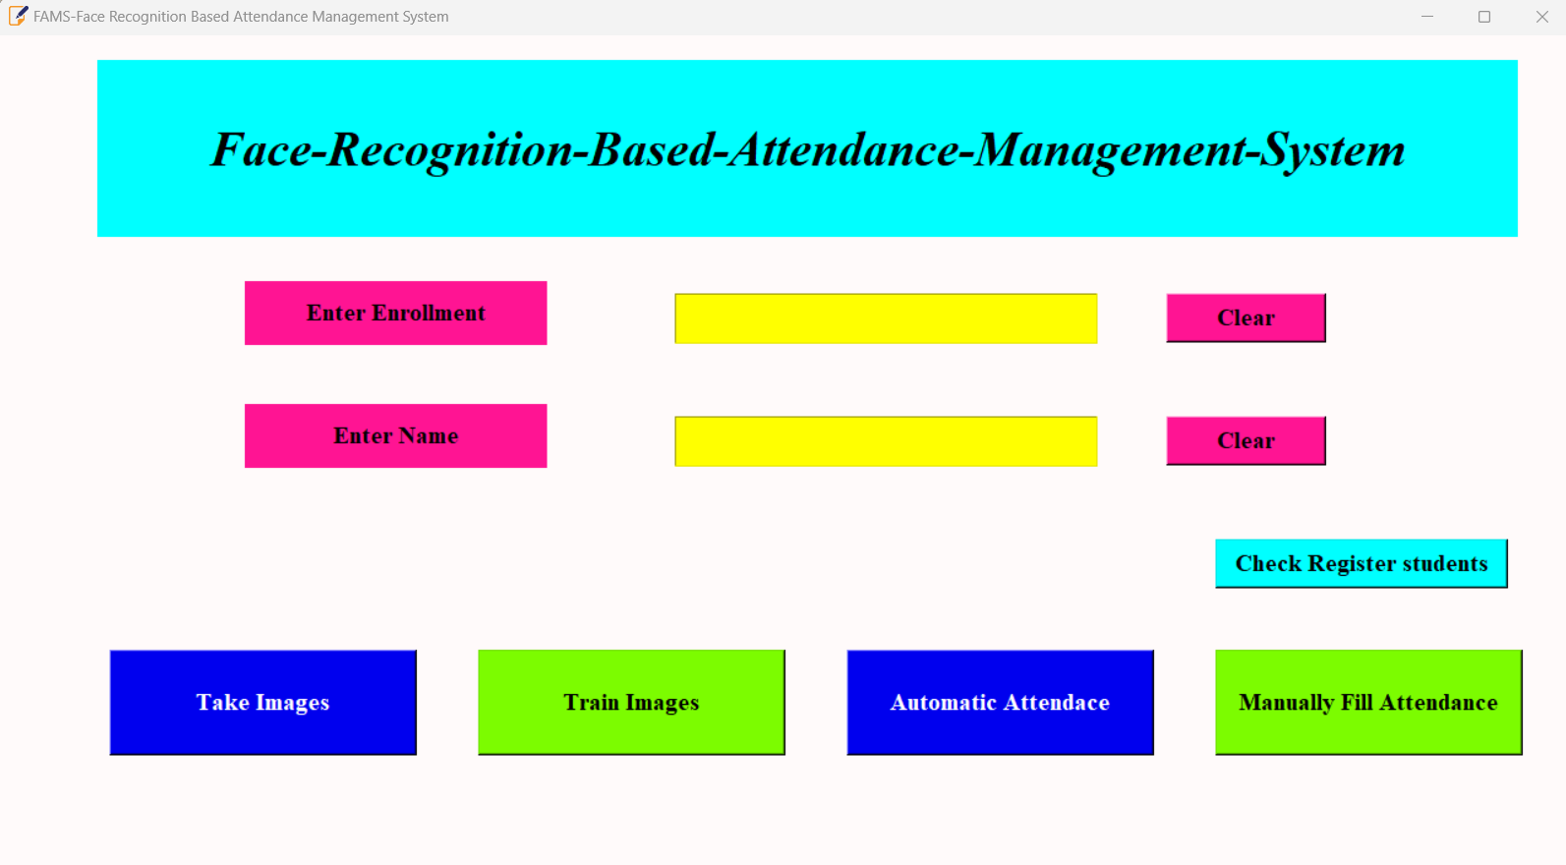

Fig 6.1 STUDENT REGISTRATION FORM

**PROFILE SAVING:**

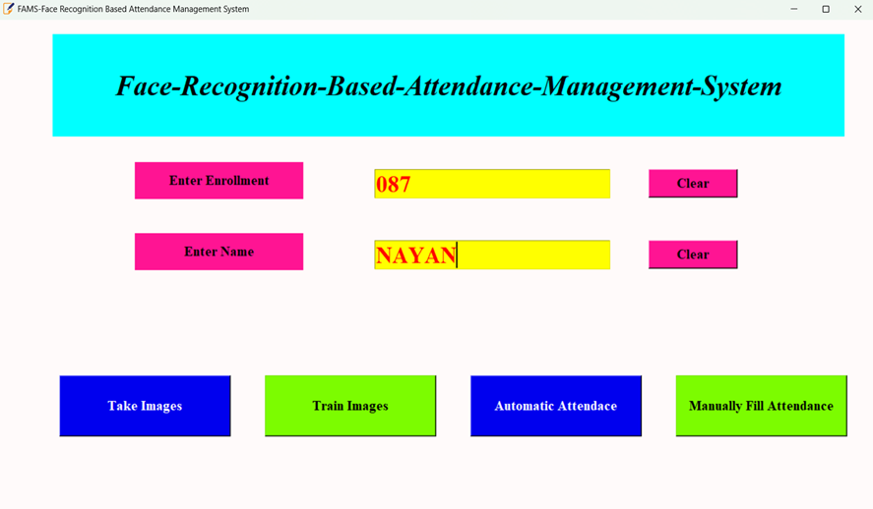

Fig 6.2 STUDENT PROFILE SAVING

## CAPTURING FACE:

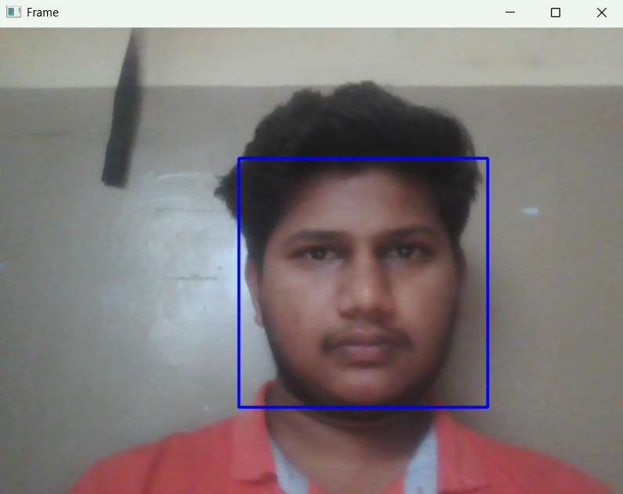

Fig 6.3 STUDENT FACE CAPTURING

**TAKING THE ATTENDENCE:**

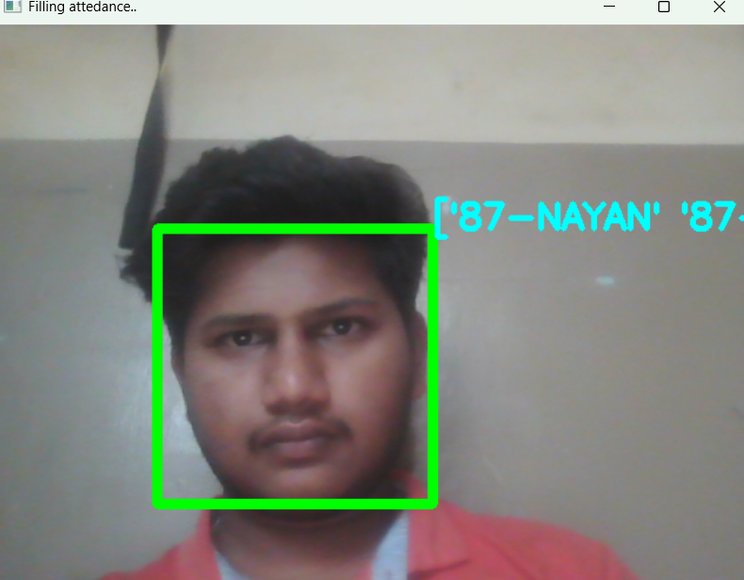

Fig 6.4 TAKING STUDENT ATTENDANCE

**STUDENTS DETAILS:**

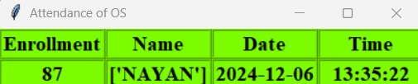

Fig 6.5 DISPLAYING STUDENT ATTENDACE

# REFERENCES

1. <https://youtu.be/WUz6nQffy2s?si=wsxhtRyUsaFivnOH>
2. <https://openai.com/index/chatgpt>
3. [https://www.python.org](https://www.python.org/)
4. [https://numpy.org](https://numpy.org/)
5. [https://opencv.org](https://opencv.org/)